AgriCL-Net: A Lightweight Continual-Learning System for Plant Disease Diagnosis
Anil Neerukonda Institute of Technology and Sciences
Affiliated to Andhra University, Sangivalasa, Visakhapatnam-531162
Submitted by Team-6B
Name | Roll Number
G. Keerthi Priya | A23126510076
U. Jahnavi | A23126510258
Md. Chandini | A23126510100
B. Rajesh | A23126510066
K. Praneeth | A23126510088
Under the guidance of Mrs. D. Anusha, Assistant Professor

Abstract
AgriCL-Net is an AI system that takes a photo of a plant leaf and returns the disease name, the infected region, a severity percentage and a severity level (Mild, Moderate or Severe), along with treatment advice. Plant diseases cause large crop losses every year, and manual inspection is slow, subjective and hard to scale.
The system separates two jobs. A class-agnostic lesion segmentation model, trained on the PlantSeg field dataset, marks diseased pixels, and SAM2 marks the leaf area, so severity is measured objectively. A Swin Transformer classifier names the disease and learns new diseases over time through replay-based continual learning with knowledge distillation, without forgetting earlier ones.
Because severity does not depend on the classifier, AgriCL-Net can estimate severity even for a disease it has not yet learned. When the classifier is unsure, it answers "Unknown" instead of guessing, and the image is saved for the next learning round. Accurate models run on a laptop or server, and distilled, quantized versions provide an offline fallback on low-cost edge devices such as a Raspberry Pi.

Problem Statement
Farmers need early, accurate and affordable disease diagnosis, but current methods fall short in five ways.
- Manual inspection is unreliable. Different people judge the same leaf differently, which leads to wrong or delayed treatment, and checking every plant does not scale to large fields.
- Most AI tools only name the disease. They do not show where the infection is or how severe it is, so farmers cannot decide how much treatment is needed.
- Models forget. When a model is retrained on a new disease, it usually forgets the diseases it learned earlier (catastrophic forgetting).
- Lab-trained models fail in the field. Models trained on clean lab photos lose accuracy on field photos with shadows, clutter and uneven lighting.
- Accurate models are heavy, and models guess. Accurate models need powerful hardware, and most systems give a confident answer even for a disease they have never seen.
There is a need for a system that is accurate on real field images, measures severity objectively, keeps learning new diseases without forgetting, admits when it is unsure, and can still work offline on affordable hardware.

Proposed Solution
AgriCL-Net is an accuracy-first diagnosis pipeline in which severity is measured independently of the disease classifier, so severity remains reliable even for diseases the system has not yet learned.

Models
Stage | Main model (accurate) | Offline fallback (lightweight)
Leaf segmentation | SAM2, pretrained, used without training | Colour thresholding (LAB / ExG)
Lesion segmentation | SAM2-UNet, binary lesion vs. background | LinkNet-ResNet18 or PDSNetx0.5, distilled from SAM2-UNet
Disease classification | Swin Transformer (Swin-T), fine-tuned | MobileNetV3, distilled from Swin-T
Explanation | Grad-CAM on the classifier | Grad-CAM on the classifier
Bounding boxes are computed from the lesion mask, so a separate detection model (DETR) is not needed. This removes one model, the box annotations and its inference time.

Key Features
- Objective severity: severity = lesion pixels / leaf pixels × 100, graded Mild (below 20%), Moderate (20% to 50%) or Severe (above 50%).
- Continual learning: the classifier learns new diseases using a replay buffer selected by herding plus knowledge distillation from the previous model.
- Unknown-disease detection: low-confidence predictions return "Unknown, consult an expert", and the image is stored for the next learning round.
- Trustworthy output: top-3 diseases with calibrated confidence, a Grad-CAM heatmap, and a consistency check between the classifier and the lesion mask.
- Two deployment modes: full-accuracy models on a laptop or server, and distilled INT8 models on a Raspberry Pi or Jetson Nano for offline field use.

Key Contribution
To our knowledge, existing continual-learning work on plant disease is limited to classification or detection, while segmentation-based severity estimation is trained once and never updated. AgriCL-Net combines class-incremental disease classification with class-agnostic lesion segmentation distilled from SAM2-UNet, so severity can be estimated even for diseases the classifier has not yet learned. This claim is tested directly by measuring severity accuracy on diseases held out of training.

System Workflow
A leaf photo is cleaned and cropped to the leaf, then split into two paths: a severity path that does not depend on the disease name, and a classifier path that keeps learning.
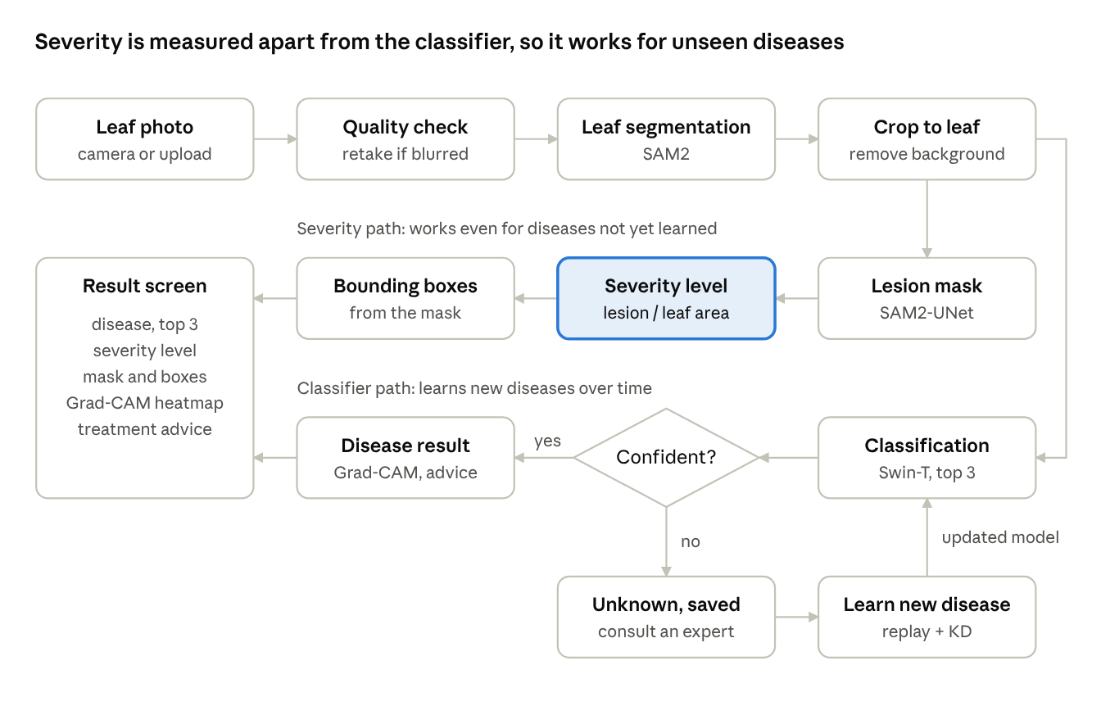
AgriCL-Net workflow · severity path, classifier path, learning loop
The severity path gives a correct severity even when the classifier answers "Unknown"; unknown images feed the learning loop that updates the classifier.

Inference Steps
- Quality check: a blurred or dark photo triggers a request to retake it.
- Leaf segmentation (SAM2): finds the leaf; if no leaf is found, the app says "No leaf detected".
- Crop to leaf: removes background clutter, the main cause of errors on field photos.
- Lesion segmentation (SAM2-UNet): marks the diseased pixels on the leaf.
- Classification (Swin-T): gives the top three diseases with calibrated confidence.
- Safety checks: confidence below the threshold returns "Unknown, consult an expert" and saves the image; a mismatch between the classifier and the lesion mask is flagged as uncertain.
- Severity: lesion pixels / leaf pixels × 100, graded Mild (below 20%), Moderate (20% to 50%) or Severe (above 50%).
- Bounding boxes: drawn around each lesion region from the mask.
- Grad-CAM: a heatmap of the regions the classifier used.
- Advice: a lookup by disease and severity level.
- Display: the Streamlit app shows all results together.

Continual Learning Loop
- Unknown images are collected and labelled by an expert as a new disease.
- A new classifier is trained on the new images, a replay buffer of about 20 images per old disease selected by herding, and knowledge distillation from the previous model (cross-entropy plus KL divergence).
- The output layer is rebalanced (weight aligning) so new classes do not dominate old ones.
- The confidence threshold is recalibrated, the model is quantized, and it is redeployed.
The lesion segmentation model does not need this loop, because a lesion is labelled the same way for every disease.

Existing Solutions
Each part of AgriCL-Net exists in earlier work, but no single system we found combines continual learning with segmentation-based severity estimation.
Work | What it does | Limitation AgriCL-Net addresses
PlantHealthNet (Iqbal, 2025) | Swin Transformer, DETR and SAM2-UNet pipeline with severity levels on PlantSeg | Too heavy for edge devices; cannot learn new diseases
PDSNets (Zhao et al., 2025) | Lightweight LinkNet-based segmentation for fast severity estimation in field images | Three diseases only; no classification or continual learning
PlantKD-CLNet (Shruthi K. S. et al., 2026) | Knowledge distillation with replay-based continual learning on edge devices | Classification only; no localization or severity
Open-world plant disease detection (Frontiers, 2023) | Flags unknown diseases and learns them later with sample replay | No severity estimation
Common mobile apps | Name the disease from a photo | No location or severity; often cloud-only; fixed set of diseases
AgriCL-Net differs by measuring severity independently of the classifier, keeping the classifier up to date through continual learning, refusing to guess on unknown diseases, and offering both a full-accuracy mode and an offline edge mode.

Datasets
AgriCL-Net uses three public datasets, chosen so that the models see both field and lab images and severity can be checked against real ground truth.
Dataset | Content | Used for
PlantSeg v7 (Wei et al., Scientific Data 2026) | In-the-wild field images of 115 diseases on 34 plants, with expert-checked lesion masks; CC BY-NC 4.0 | Lesion segmentation and disease classification
PlantVillage (Hughes and Salathé, 2015) | Lab images of leaves on plain backgrounds | Extra classification data, mixed with field images for robustness
PDSNets dataset (Zhao et al., 2025) | 240 field images of three diseases, labelled as background, healthy leaf and disease spot | Severity ground truth, leaf-mask check and unseen-disease test

Data Preparation
- All PlantSeg disease classes are merged into one "lesion" class for segmentation; the disease names are kept as classification labels.
- Diseases are grouped by crop to form the continual-learning rounds.
- Some diseases are held out of all training and used only to test severity on unseen diseases.
- Augmentation covers field conditions: colour jitter, rotation, flips, scaling and random erasing.
PlantSeg masks label only diseased pixels, not healthy leaf area, so the leaf area is obtained from SAM2. The exact image count of PlantSeg v7 and the overlap between PlantSeg and PDSNets diseases will be confirmed after download.

Requirements

Functional Requirements
- Accept a leaf photo from a camera or file upload, and ask for a retake if the photo is blurred or too dark.
- Segment the leaf and the diseased regions at the pixel level.
- Classify the disease and show the top three predictions with confidence scores.
- Return "Unknown, consult an expert" when confidence is below a calibrated threshold.
- Calculate the severity percentage and level (Mild, Moderate or Severe).
- Draw bounding boxes around infected regions and show a Grad-CAM heatmap.
- Give treatment advice based on the disease and its severity.
- Learn new diseases after deployment without forgetting earlier ones.
- Run offline on an edge device in fallback mode.

Non-Functional Requirements
- Accuracy: reliable diagnosis on real field images, not only lab images.
- Trustworthiness: calibrated confidence, and no confident answer for an unknown disease.
- Speed: results within a few seconds per image.
- Usability: a simple interface that a farmer can use without training.
- Low cost and offline use: a fallback mode on affordable hardware without internet.
- Scalability: new diseases can be added over time.

Hardware Requirements
Purpose | Requirement
Model training | Google Colab or Kaggle notebook with an NVIDIA GPU (e.g. Tesla T4)
Development and main app | Intel Core i5 / AMD Ryzen 5 or higher, 8 GB RAM minimum (16 GB recommended), 20 GB free storage (SSD preferred)
GPU (optional) | NVIDIA GTX 1650 or better, for faster local inference
Field deployment (fallback) | Raspberry Pi 4 or Jetson Nano, camera module and power bank
Internet | Needed for setup, dataset download and training; not needed in offline mode

Software Requirements
Category | Tools
Language and OS | Python 3.11 on Windows 10/11 or Ubuntu 20.04+
Deep learning | PyTorch, Torchvision, Swin Transformer, SAM2, SAM2-UNet
Image processing | OpenCV, NumPy, Pillow
Evaluation and plots | scikit-learn, Pandas, Matplotlib
Deployment | ONNX Runtime with INT8 quantization
Interface | Streamlit
Annotation (new diseases) | LabelMe
Version control | Git and GitHub

Evaluation Plan
The most important experiment is severity accuracy on diseases held out of training, because it tests the project's key contribution.
What is evaluated | Metrics | Compared against
Disease classification | Top-1 and top-3 accuracy, F1-score, confusion matrix | PlantHealthNet's reported classifier results
Confidence quality | Expected calibration error, unknown-detection AUROC | Classifier before and after temperature scaling
Lesion segmentation | IoU, Dice coefficient | Teacher vs. distilled student vs. quantized student
Leaf segmentation | IoU on the PDSNets dataset | SAM2 vs. colour thresholding
Severity estimation | R², RMSE, Mild/Moderate/Severe confusion matrix | PDSNets' reported R²
Unseen-disease severity | R² and RMSE on held-out diseases | Same metrics on diseases seen in training
Continual learning | Average incremental accuracy, forgetting measure | Plain fine-tuning (lower bound) and joint training on all data (upper bound)
Edge deployment | Model size (MB), latency (ms), accuracy | Models before and after INT8 quantization

Stakeholders
AgriCL-Net serves the people who diagnose and treat crop disease, the people who act on regional disease data, and the people who build and maintain the system.
Stakeholder | Role and benefit
Farmers and agricultural producers | Primary users: capture a leaf photo, get the disease, severity and advice, act early and apply only the treatment needed
Agronomists and plant pathologists | Get objective, pixel-level severity data; review "Unknown" cases and label new diseases for the next learning round
Agricultural extension officers and cooperatives | Monitor disease spread across regions and warn farmers early
Agri-tech developers and hardware manufacturers | Integrate the lightweight models into apps, drones, robots and sprayers
Government and food security authorities | Use aggregated, anonymized disease data for planning and outbreak response
System administrator | Manages model updates, edge-device deployments, performance monitoring and data security
Development team | Builds, trains, tests and maintains the models, the continual-learning pipeline and the Streamlit app
Researchers and educational institutions | Use the system as a base for further research and teaching in agricultural computer vision

Relation to Society
AgriCL-Net helps protect food supply and rural income by making accurate disease diagnosis available to farmers who lack expert access.
- Protects food supply: early detection reduces crop loss and supports food security.
- Reduces pesticide overuse: measured severity lets farmers treat only where and as much as needed, which is better for the environment.
- Helps small farmers: the offline mode works on cheap devices without internet, so it is not limited to farmers who can afford expensive tools.
- Protects rural income: preventing crop loss protects the main income of farming families.
- Builds trust: the system says "Unknown" instead of guessing and shows why it made a decision.
- Stays useful over time: continual learning keeps the system up to date as new diseases appear.

References
- Zhao, C. et al. "Plant Disease Segmentation Networks for Fast Automatic Severity Estimation Under Natural Field Scenarios." Agriculture, 15, 583, 2025. doi.org/10.3390/agriculture15060583 (base paper 1)
- Iqbal, A. "PlantHealthNet: Transformer-Enhanced Hybrid Models for Disease Diagnosis and Severity Estimation in Agriculture." IEEE Access, 13, 2025. doi.org/10.1109/ACCESS.2025.3576990 (base paper 2)
- Shruthi K. S. et al. "Knowledge Distillation-Driven Continual Learning for Lightweight Plant Disease Detection on Edge Devices." Ingénierie des Systèmes d'Information, 2026. doi.org/10.18280/isi.310123
- Wei, T. et al. "A Large-Scale In-the-Wild Dataset for Plant Disease Segmentation" (PlantSeg). Scientific Data, 13, 205, 2026. Dataset: zenodo.org/records/17719108
- "A New Deep Learning-based Dynamic Paradigm Towards Open-World Plant Disease Detection." Frontiers in Plant Science, 2023. doi.org/10.3389/fpls.2023.1243822
- Liu, Z. et al. "Swin Transformer: Hierarchical Vision Transformer using Shifted Windows." ICCV, 2021.
- Kirillov, A. et al. "Segment Anything." ICCV, 2023.
- Ravi, N. et al. "SAM 2: Segment Anything in Images and Videos." arXiv, 2024.
- Xiong, X. et al. "SAM2-UNet: Segment Anything 2 Makes Strong Encoder for Natural and Medical Image Segmentation." arXiv, 2024.
- Rebuffi, S. et al. "iCaRL: Incremental Classifier and Representation Learning." CVPR, 2017.
- Hinton, G., Vinyals, O. and Dean, J. "Distilling the Knowledge in a Neural Network." arXiv, 2015.
- Guo, C. et al. "On Calibration of Modern Neural Networks." ICML, 2017.
- Selvaraju, R. R. et al. "Grad-CAM: Visual Explanations from Deep Networks via Gradient-based Localization." ICCV, 2017.
- Hughes, D. and Salathé, M. "An Open Access Repository of Images on Plant Health to Enable the Development of Mobile Disease Diagnostics" (PlantVillage). arXiv, 2015.

